Photokinesis and Phototaxis are two ways animals can respond to light. Photokinesis is when an animal increases or decreases their activity levels in response to light, without orientation. For example, fiddler crabs freeze when a bright light shines on them. In contrast, some fish swim faster in brighter light than in the dark. These are both examples of photokinesis. Phototaxis is when an animal orients with respect to a light source. This behavior is usually accompanied by locomotion towards or away from the light. An animal that orients towards a light source is exhibiting positive phototaxis, while an animal orienting away from a light source is exhibiting negative phototaxis. For example, moths often fly towards lamps—this is an example of positive phototaxis. In contrast, earthworms will move away from light sources in order to prevent themselves from drying out—this is an example of negative phototaxis.
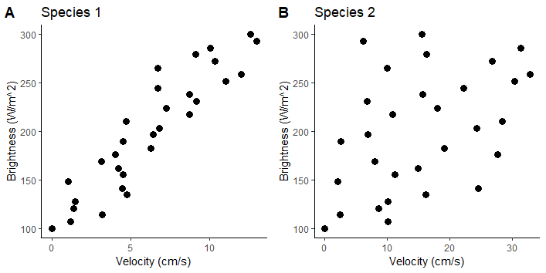
A researcher was digging around in her garden and found a bunch of pill bugs, or roly-polies (Armadillidium Spp.), hiding under a rock. These small gray isopods seemed startled by the bright light and started scurrying about. The researcher hypothesized, from watching them, that they were exhibiting photokinesis, and moved faster when exposed to bright light. To test her hypothesis, she collected 30 pill bugs and then released them one at a time from a dark box into a room with adjustable light-levels. She hypothesized that the isopods would move faster if they were released into a room with brighter light. Her results are shown below in figure 1A. She then decided to repeat her experiment using another species of isopods that are more active during the daytime. Again, she hypothesizes that the isopods would move faster if they were released into a room with brighter light. Her results with the second species are shown below in figure 1B.
Figure 1: The speed at which the isopods moved when released into a room, versus the brightness level of the room itself.

Q1: Based on figure 1, do you think the researchers’ hypotheses were supported? What are some important differences between species 1 and species 2?
Q2: Suggest an experiment to test if the isopods exhibited phototaxis instead of photokinesis?

